For my scene, I’m going to create models of these four items: A paper towel, a pencil, a battery and a cell phone (pic was taken with cell phone, phone in pic is placeholder). These objects will rest atop a wood desk. These items contain many different primitive shapes.

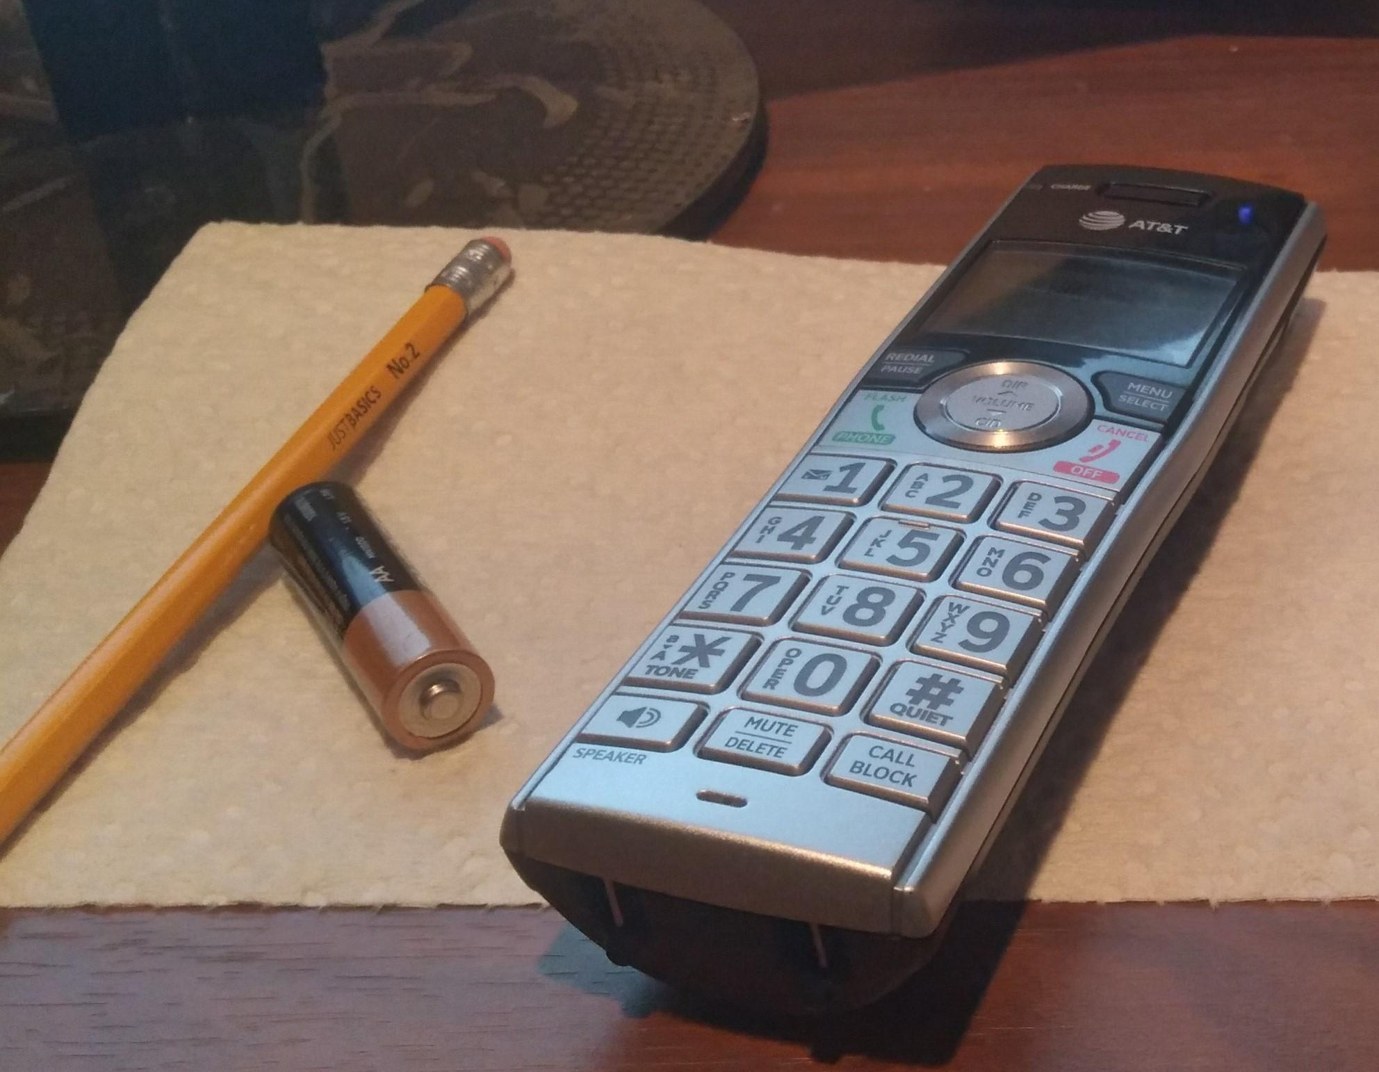

For the paper towel, given its features, it will be a flat plane model. The pencil has two primitive objects: a cylinder for the base and a pyramid for its point. The battery is another object that contains more than one primitive object. The battery is essentially a cylinder with a sphere on top. Finally, the cell phone consists of a rectangle with one side curved inwards. For the cell phone touchscreen, a plane could be added for more detail. I feel that these objects have the right balance of being not too complex or too simple to implement. Most of these models are complex objects containing one or more primitive objects. Yet their shapes aren’t too complex to implement. An example of a complex object to create would be a computer keyboard. These have different keys with varying sizes. Given how many keys there are on a keyboard, this can become complex quickly. Due to these reasons, these are the objects I have chosen for my project.